Plainville United Methodist Church

Peace Garden
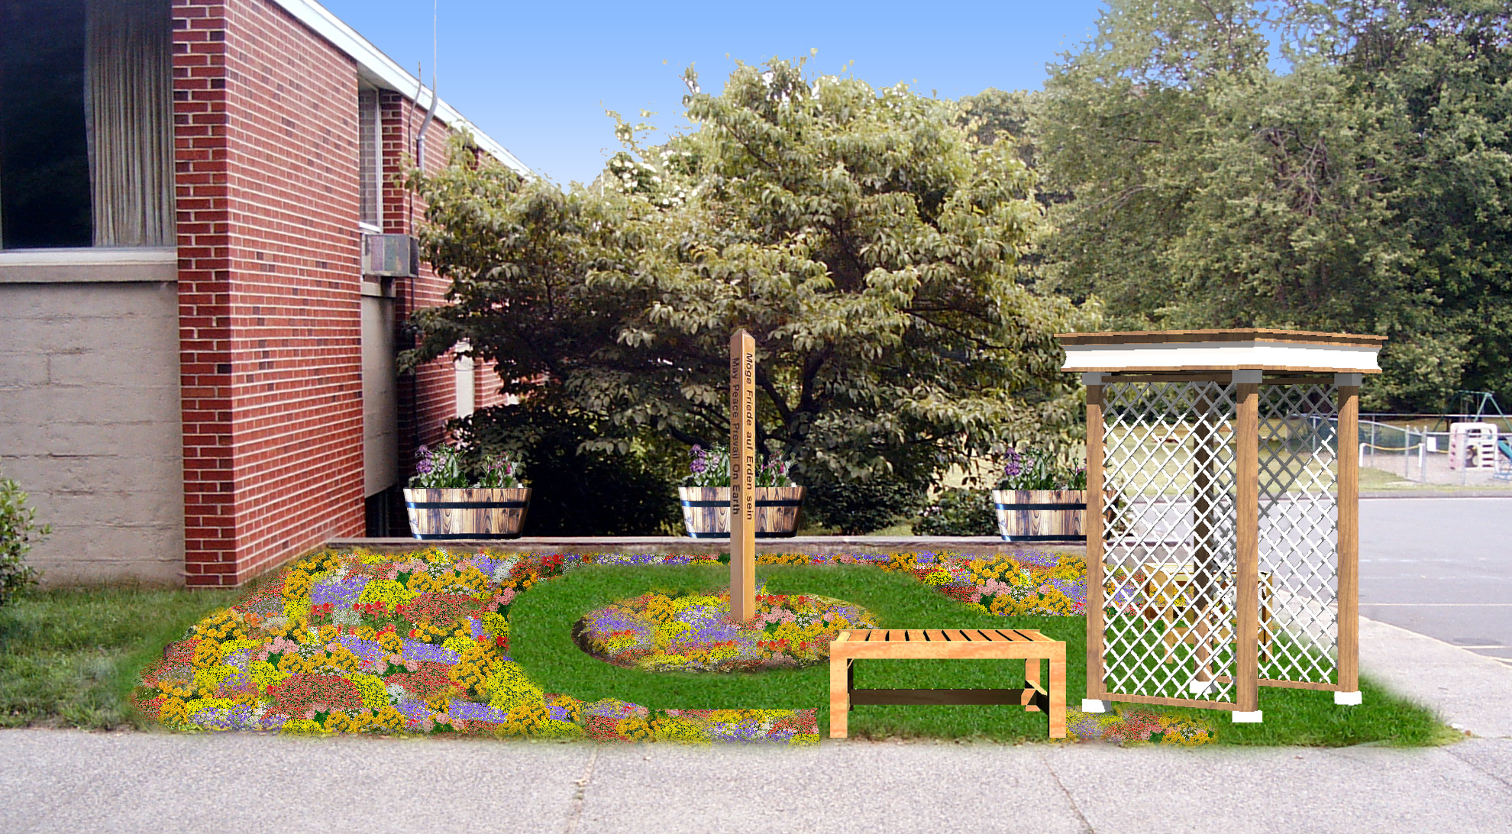


Eagle Scout Project Proposal

Woody Underwood
Troop 30, Plainville

Questions about this project can be directed to Woody Underwood:

22 Canterbury Lane
Plainville, CT 06062

Phone: (860) 747-9829
Fax: (860) 747-9829
Email: woody@underwoods.org

This proposal has a companion website which can be accessed at:

http://eagle.underwoods.org/

You can download a copy of this proposal in several formats from the website.

The Peace Pole Project
Questions and Answers

Here are the answers to some basic questions about peace poles and my proposed project.

What will the project consist of?
A peace pole will be planted on church grounds, and various flowers and greenery will be added in the surrounding area. Two benches, three planter boxes, and an arbor will also be inserted, and a dedication ceremony for the completed garden and peace pole will be held. In addition, a time capsule in which people may request to put certain items will be buried beneath the peace pole.

What is a peace pole?
A peace pole is a pole, usually eight feet high with four or more sides, each with the statement “May peace prevail on Earth” in a different language.

Where will the peace pole and time capsule be planted?
In the area to the right of the narthex (when viewed from the outside) at the corner by the parking lot.

When will the pole be planted?
While the garden will ideally be completed by the end of August, due to the time it will take to order and receive the peace pole, it may be planted in the fall or the spring.

Who will pay for the pole, time capsule, and other supplies?
Donations will be sought from companies and individuals who are willing to contribute. There will be no cost to the church.

Who will plant the pole and capsule, and create the garden?
Labor will be performed primarily by volunteers from Boy Scout Troop 30.

Who will maintain the garden?
Since it is not the nature of an eagle project to be an ongoing project, I cannot be responsible for maintaining the garden. However, I will attempt to make the garden as low-maintenance as possible without sacrificing its beauty.

How will this benefit the church?
In a time of much violence and turmoil in the world, a peace garden on church grounds supports the widespread thought that peace is needed in the world, and will assist in supporting the church’s positive reputation in the community. In addition, the time capsule will allow the church to send a message of peace to future generations.

Project Details

Project Location:
The peace garden will be created on the rectangular plot of land at the corner of the sidewalk by the parking lot to the right of the narthex at the Plainville United Methodist Church, 56 Red Stone Hill, in Plainville, CT. This three hundred seventy-eight square foot garden is a prominent landmark when driving into the church parking lot, and will be seen not only by the congregation, but also other groups like the Boy Scouts, Girl Scouts, and Alanon.

Project Purpose:
The purpose of the garden is to promote peace in a turbulent, violent world. The garden can serve as a place of meditation for both church members and the community.

Project Outline:
- Arbor and Benches
- Plantings
- Time Capsule
- The Peace Pole
- Dedication Ceremony

Step 1: Arbor and Benches
An arbor and two benches will be installed in the garden to set it off from the sidewalk and parking lot, and also providing a peaceful place to sit and enjoy the garden. The arbor will be placed in the corner of the garden where the two sidewalks meet, and the benches perpendicular to one another on both sides of the arbor. The arbor and benches will be made by volunteers and myself.

Step 2: Plantings
Flowers of types appropriate to the theme of the garden will be planted as shown on the “Before and After” page. Peace roses will be planted on both sides of the arbor. If such roses exist, climbing peace roses will be used. Three planter boxes will be put on the stone wall at the back of the garden to act as a guard so people will not fall off the ledge. Grass will also be restored to make a pathway to walk around the peace pole.

Step 3: Time Capsule
A time capsule will be planted in the center of the garden beneath the base of the peace pole. Church members will be able to request to include small items or messages of peace inside the capsule. The purpose of the capsule is to send a message of peace to the future, and it is not intended to be used as a “church heritage” capsule. A capsule with that purpose already exists on church grounds. What the time capsule will be made of has yet to be determined. Various options have been considered, each with their own advantages and disadvantages. See attached sheet “Time Capsule Options” for details.

Step 4: The Peace Pole
The peace pole will be inserted in the center of the garden, surrounded by flowers and other plants. The languages that will be included on the pole will be determined by polling the church congregation, with English being included by default. Unless there is a demand for more than four languages on the pole, a four sided cedar pole will be inserted, though six and eight sided poles are available. At the request of the Trustees, a pole with languages engraved directly in the pole rather than on plaques will be sought. Details about the pole that has been unofficially selected for the garden can be found in the “Project Goals” section.

Step 5: Dedication Ceremony
A ceremony will be held for the dedication of the garden and the peace pole. Local clergy, political leaders and other persons will be asked to attend and/or speak at the ceremony. State leaders may also be invited. The ceremony will be staffed by volunteers from Troop 30 and/or other troops. Refreshments may be provided. Decorations like flags of U.N. nations, or a peace banner may be used during the ceremony.

Project Time Schedule, Hour Count, and Participants

Planning, Seeking of Donations and Consultation, and Fund Raising:
Time Period: July and early August
Estimated Hour Count: 75-100 Hours
Hours Spent to Date: 15-20 Hours (plus 15-20 Hours on original proposal)
Participants: Woody Underwood, Mitch Underwood Jr.

Physical Work
Time Period: Mid to late August
Estimated Hour Count: 50-75 Hours
Hours Spent to Date: N/A
Participants: Woody Underwood, Mitch Underwood Jr., Gregory Prisloe (for carpentry work), 1-4 other adults, 10-15 scouts

Peace Pole Planting
Time Period: Fall 2004, or spring 2005
Estimated Hour Count: 1-2 Hours
Hours Spent to Date: N/A
Participants: Woody Underwood, Mitch Underwood Jr., 1-4 other adults, several scouts

Dedication Ceremony
Time Period: Early October
Estimated Hour Count: 40-60 Hours
Hours Spent to Date: 1-2 Hours
Participants: Woody Underwood, Mitch Underwood Jr., 1-4 other adults, 10-15 scouts
Actual ceremony will be approximately one hour.

Funding the Project

Major Purchases and Estimated Cost
- Peace pole, $300
- Time capsule, $100
- Various plants, $300-$500
- Lumber for benches, arbor, and planter boxes: $250
- Refreshments for dedication ceremony, $100-$200

Funding Plans
Donations will be sought to pay for all supplies. An anonymous individual has already volunteered to donate the peace pole. Local businesses will be asked to donate other supplies. The Trustees of the church have mentioned that funds may be available for supplies that cannot be donated.

Fund Raising
Fund raising will probably be necessary. Friends and family will be sought out for whatever donations they are willing to make. I estimate requesting fund raising donations from nearly one hundred people. If possible I would like to work something out so that these donations can be made to the church (thus being tax deductible), and then made available to me for the project.

Excess Funding
If extra funds remain after the completion of the project and no use in the garden can be found for them, the funds will be entrusted to the church to be used for garden maintenance and improvement in the future. All funds that were donated for the garden will be put towards the garden.

Time Capsule Options

Any of several different materials may be used to create a time capsule. Below is an overview of different materials and the positive and negative aspects of each. These will be carefully considered when determining what material to use for the capsule.

Option 1: Schedule 40 PVC Pipe
Advantages: Inexpensive, easily sealed, available in many sizes
Disadvantages: Decomposes over time, releasing hydrochloric and acetic acid, which can damage archived documents
Note: This option has been eliminated.

Option 2: Polyethylene Pipe
Advantages: Relatively inexpensive, relatively stable, has history of being used as time capsules
Disadvantages: Polyethylene usually has comparatively thin walls, thus subject to damage

Option 3: Polypropylene Pipe
Advantages: Relatively inexpensive, relatively stable, has history of being used as time capsules, thick enough to be threaded for proper sealing
Disadvantages: Difficult to obtain in appropriate diameters, possibly difficult to properly seal if threading is not possible

Option 4: Glass Bottles
Advantages: Inexpensive, readily available, last indefinitely
Disadvantages: Freezing and thawing of soil can cause bottle to break

Option 5: Aluminum or Stainless Steel
Advantages: Most common type of time capsule, most resistant to degradation
Disadvantages: Very expensive to purchase and to seal
Note: This type of capsule is preferred if the funding is available.

Other time capsule considerations include determining how to archive documents and items put into the capsule so that they will not degrade. Usually chemical packets are put in the capsule along with the documents to soak up oxygen and water. Another method is to purge the capsule with nitrogen, though this is rather technically difficult and expensive. The type of paper used must also be considered. Only dried, acid-free paper will last for extended periods in a capsule. One possibility, since this paper is costly, is to have church members leave messages on regular paper and then create a photographic record or group compilation of these papers.

Cleveland, Marjorie, et al. “SCMRE Time Capsules.” Smithsonian Center for Materials Research and Education. Aug. 2002. The Smithsonian Institution. 13 Aug. 2003 <http://www.si.edu/scmre/takingcare/timecaps.htm>

“Time Capsules.” National Preservation Office. 6 Aug. 2003. The British Library. 13 Aug. 2003 <http://www.bl.uk/services/preservation/time.html>

Project Goals

Site as it is now:

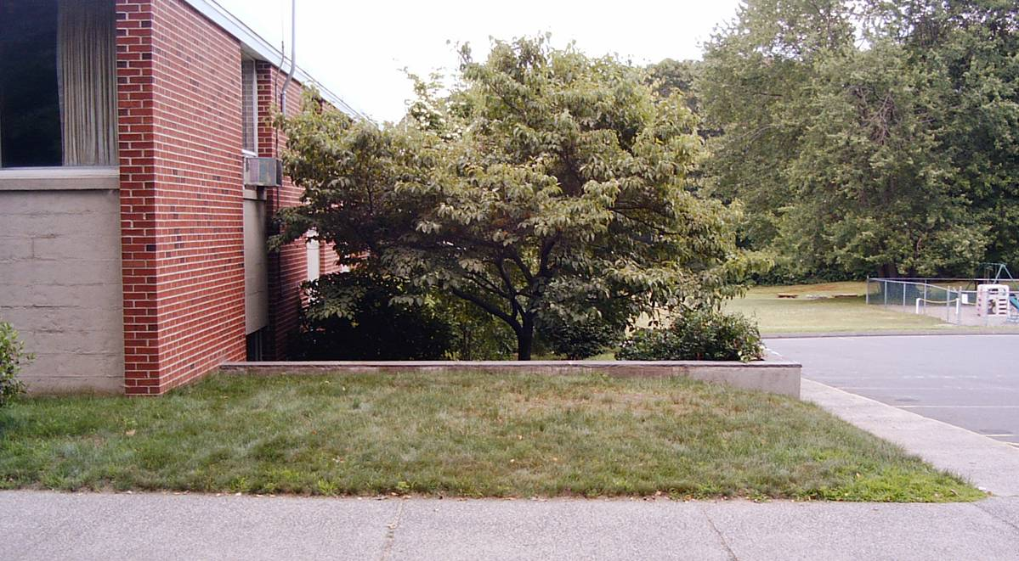

Garden after project completion (simulated):

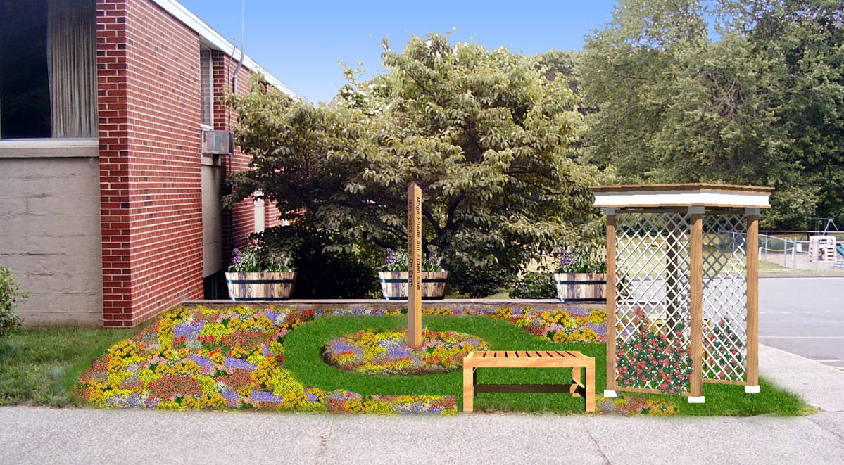

Addendum
The following pages are taken from various websites. The information from these sites was either referred to within the previous page s or is helpful additional material. Citations to the sources of this information have been included.


A Peace Pole acts as a silent prayer
and message for peace on Earth.
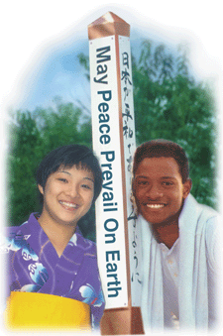
What is a Peace Pole?
A Peace Pole is a hand-crafted monument that displays the message and prayer May Peace Prevail on Earth on each of its four or six sides, usually in different languages. There are more than 200,000 Peace Poles in 180 countries all over the world dedicated as monuments to peace. They serve as constant reminders for us to visualize and pray for world peace.
Usually a Peace Pole is eight feet tall (2m 50cm) with the bottom "planted" in the ground, although many indoor Peace Poles are supported by stands. It may be constructed from any material that is environmentally sound. In the United States, most Peace Poles are made from western red cedar, a wood that is a renewable resource. Peace Poles may be made from any local hard wood, or from plastic or metal.

When and Where to Plant a Peace Pole
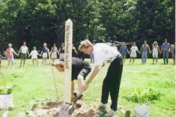

Peace Poles are often planted to commemorate special occasions, such as holidays, anniversaries, events and festivals. Or any date may be chosen to dedicate a place to peace.
A Peace Pole may grace a town square, a school, a park, a place of worship, an office or a garden. Or they can put forth your community as an example of how to live in peace. Whatever the location, the presence of a Peace Pole announces that this is a special place, dedicated to peace on Earth.
Planting a Peace Pole is a way to bring people together on an inspiring project to join in a network of peace consciousness that is emerging all over the world. It is a wonderful project for any community group, from children to senior citizens.
Peace Poles Around the World
When you plant a Peace Pole in your community, you are linking with people all over the world who have planted their Poles in the same spirit of peace. Every Peace Pole proclaims the prayer May Peace Prevail on Earth in the language of the country and often several other languages as well.
The more than 200,000 Peace Poles around the world are on all continents, in every country you can think of. They are in simple places, such as churches and gardens, and extraordinary ones, such as at the Pyramids of El Giza, Egypt or the Magnetic North Pole in Canada. They are promoting healing of conflict in places like Sarajevo and the Allenby Bridge between Israel and Jordan. The photos above and below are at the campus of the School of Metaphysics in Windyville, Missouri.

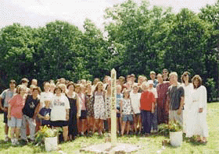

Mayors in many parts of the world have planted Peace Poles to dedicate their cities and towns to world peace. Both political leaders, such as former U.S. President Jimmy Carter, and religious leaders, such as Pope John Paul II, Mother Teresa and the Dalai Lama, have dedicated Peace Poles.
Your Peace Pole Dedication Ceremony
A Peace Pole dedication ceremony is an exciting event, whether it is planned for a public place where hundreds of people will attend or a private backyard. Every dedication ceremony is a unique outcome of the shared experience of those who plan the program, as well as those who attend. Here are some suggestions that you may consider in the creation of your Peace Pole dedication ceremony:
• Invite your community to participate in the ceremony, including children and senior citizens, representatives of various faith communities and/or ethnic groups, schools, clubs, scouts and local media. Community leaders and clergy love to be asked to make speeches!
• Explain the history and origin of the Peace Pole Project, how you learned about it, why the particular languages were selected, and the significance of the site and date.
• Choose, if you like, an inspiring spiritual passage, litany, poem or prayer for the occasion.
• Have the peace messages on the Pole read in the four (or more) different languages by designated individuals with a connection to each language or culture.
• Invite local groups to provide entertainment, such as a church choir or a children's dancing school. It is nice to end with everyone singing together.
Tips:
Some Peace Poles are already placed in the ground prior to the ceremony and unveiled during the dedication. Or you may choose to have a group planting, where everyone gets to heave a shovelful of dirt.
Various items may be planted along with your Peace Pole.
A dedication plaque is particularly appropriate for Peace Poles in public places, so that everyone will know what your Pole stands for.
Plan a re-dedication ceremony for the following year.
Remember that your Peace Pole dedication or re-dedication can include any elements you bring to it. Whatever you do, the important part is to hold a prayer for world peace in your heart and send it around the world. You will make it special - you will be a bringer of peace.
You cannot go wrong if you plan your Peace Pole dedication with lots of love!
“Peace Poles.” The World Peace Prayer Society. The World Peace Prayer Society. 13 Aug. 2003 <http://www.worldpeace.org/peacepoles.html>

Peace Pole Data
Peace Poles Around the World: Over 200,000
Countries With Peace Poles: Over 180
Extraordinary Locations:

Magnetic North Pole, Canada | Confucious Burial Site, Taiwan
Pyramids of El Giza, Egypt | Gorky Park, Russia
Findhorn Foundation, Scotland | Robben Island, South Africa
Jordan River, Israel | Atomic Bomb Dome, Hiroshima
The Hague, Netherlands | 2002 Winter Olympics - Utah, US

Peace Poles at the 2002 Winter Olympics
-
The Olympic Peace Pole Path
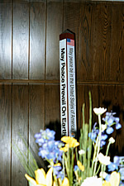
The Salt Lake Olympic Committee has approved a path of 80 Peace Poles at the Olympic Village, one representing a prayer for peace for each participating country. The Olympic Peace Pole Path will be a permanent legacy to Salt Lake City and a reminder of the meaning of the Olympic Truce. An additional 80 Peace Poles will be donated to each country's athletic delegation to take home with them. The Peace Poles will be dedicated at the first interfaith service of the Games organized by the Olympic Chaplains Committee on February 3, 2002.
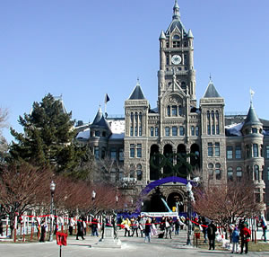
Each 4-sided Peace Pole will say "May Peace Prevail on Earth" in the official Olympic languages, French and English. A third side will have the flag of the United Nations on top, with the text:
"The Modern Olympic Truce is passed in a resolution at the United Nations before each Olympics. It is a reinstitution of the ancient Olympic Truce. The Truce attempts to build upon the friendship, solidarity and cooperation between nations that are at the heart of the true Olympic spirit."
The fourth side of each Peace Pole will display the country's flag, with "May Peace Prevail in [that nation]" in the national language. At the bottom will be the Salt Lake Olympic logo.
The Olympic Torch Lighting ceremony in Miami, Florida on December 8, 2001 is being held in conjunction with the dedication of a Peace Pole sponsored by Office Depot. This event serves to deepen the connection between the Olympic Flame and the message "May Peace Prevail on Earth."
The 2002 Winter Olympics
The Winter Olympic Games will be held in Salt Lake City,Utah from February 8-24, 2002.
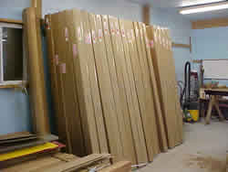
The Olympic Village at the campus of the University of Utah is on the site of a former military base. Amid increased security considerations, Salt Lake City stands poised to celebrate excellence in athletic achievement and the magnificence of the human spirit.
In this time of crisis for our country, the 2002 Winter Olympics can inspire the world with the tradition of peaceful competition and friendship among nations.

“Peace Pole Makers USA- About Us.” Peace Pole Makers USA. Peace Pole Makers USA. 13 Aug. 2003 <http://www.peacepoles.com/about_us.shtml>

